Major Project, Assignment 5 (100 Points)

**Chapter 1-9 CSDA 5210 – Databases and Data Warehouses**

**TEAM Members: Nikroshitha A Notani , Sreeja Reddy Singidi**

# Parts 1, 2, 3 & 4 Include the most current:

## Scenario Description

We designed a database system for Car Rental. This system required several entities: Customer, Account, Car, Order, Store, and Store Representative . One Customer is allowed to have only one Account, and only one Store Representative supervises one car. A Customer can rent more than one car, and more than one Customer can rent one car.

Only one Customer could appear at a single Order Place for the Order Process, and more cars can exist in a single Order Entity 1 Entity 2 Cardinality Customer has Account 1 : 1 Customer Rent Car n : n Customer Places Order 1 : n Order Holds Car n : n Store Displays Car 1 : n Store Executive Maintains Store 1 : 1 Place. Many cars are allowed to be maintained in a store. Therefore, there are two 1-to-1 binary relationships, two 1-to-n binary relationships, two n-to-n binary relationships.

## ER Diagram

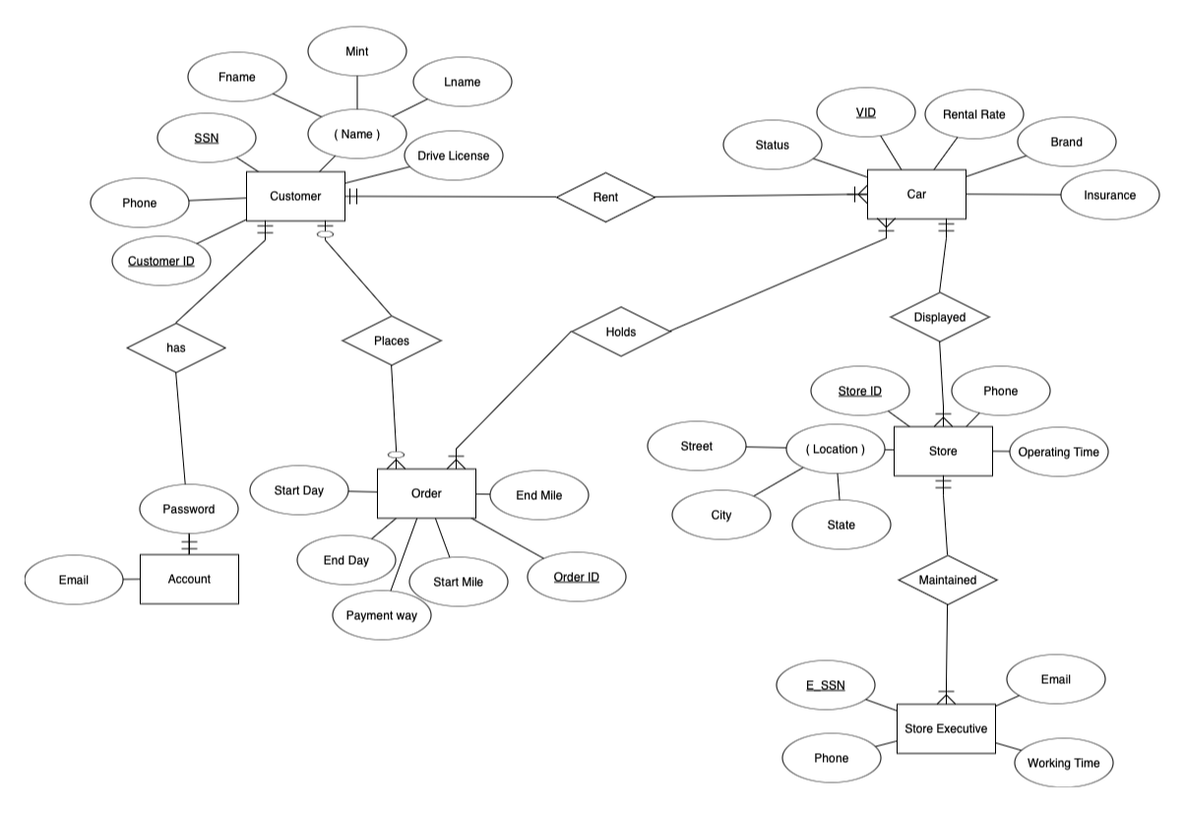

## Entities

|  |  |  |
| --- | --- | --- |
| Account | Email | Varchar |
|  | Password | Varchar |
|  |  |  |
| Customer | Name | Varchar |
|  | Fname |  |
|  | Lname |  |
|  | Mint |  |
|  | Ssn | Varchar |
|  | Phone | Varchar |
|  | Customer_ID |  |
|  |  |  |
| Car | Brand | Varchar |
|  | VID | Varchar |
|  | Rental_rate | Varchar |
|  | Status |  |
|  | Capacity |  |
|  | Detail |  |
|  | Type |  |
|  | Insurance |  |

|  |  |  |
| --- | --- | --- |
|  |  |  |
| Store | Store_ID | Varchar |
|  | Operating_time | Varchar |
|  | Phone | Int |
|  | Location |  |
|  | Street |  |
|  | City |  |
|  | State |  |
|  | ZIP |  |
|  |  |  |
| Store Executive | E_ssn | Varchar |
|  | Phone | Varchar |
|  | Email | Varchar |
|  | Working_time | Varchar |
|  |  |  |
| Order | OrderID | Int |

|  |  |  |
| --- | --- | --- |
|  | Start_Day | Varchar |
|  | End_Day | Varchar |
|  | Start_Mile | Varchar |
|  | End_Mile | Varchar |
|  | Payment_way | Int |

## Relationships

|  |  |
| --- | --- |
| Type of the binary relationship | Relationships in the system |
| one-to-one | Store assigns only one Store Executive to Supervise one customer |
| one-to-many | 1. One customer can place many orders. 2. One Store can maintain many cars. All cars are maintained only in one store. 3. Car has a 1:M to Store 4. Customer has a 1:M between Order. |
| many-to-many | Customers can rent many cars. Each customer can rent 2 or more cars.  All Cars placed in the orders contains the car information |

## Relational Schema Diagram

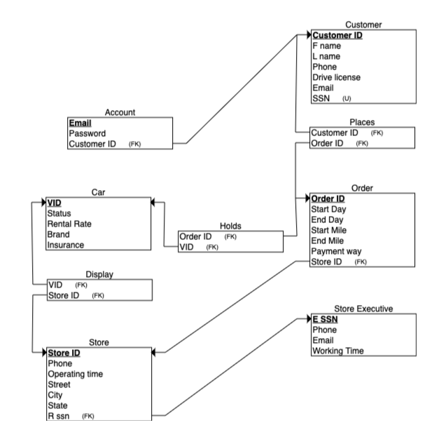

# SQL CREATE script

CREATE TABLE P_Customer

(

Customer_ID INT NOT NULL PRIMARY KEY,

F_name VARCHAR(20) NOT NULL,

L_name VARCHAR(20)NOT NULL,

Phone INT NOT NULL,

Driving_License VARCHAR(20) NOT NULL,

Email VARCHAR(20) NOT NULL,

SSN INT NOT NULL UNIQUE

);

CREATE TABLE P_Store_Executive

(

E_SSN INT NOT NULL PRIMARY KEY,

phone INT NOT NULL,

Email VARCHAR(20) NOT NULL,

Working_time INT NOT NULL

);

CREATE TABLE P_Account

(

Email VARCHAR(20) NOT NULL PRIMARY KEY,

Password VARCHAR(20) NOT NULL,

Customer_ID INT NOT NULL,

FOREIGN KEY (Customer_ID) REFERENCES P_Customer(Customer_ID)

);

CREATE TABLE P_Store

(

Store_ID INT PRIMARY KEY,

Phone INT NOT NULL,

Operating_time INT NOT NULL,

Street VARCHAR(20) NOT NULL,

City VARCHAR(20) NOT NULL,

State VARCHAR(20) NOT NULL,

E_SSN INT NOT NULL,

FOREIGN KEY (E_SSN) REFERENCES P_Store_Executive(E_SSN)

);

CREATE TABLE P_ORDER

(

Order_ID INT PRIMARY KEY,

Start_Day VARCHAR(30) NOT NULL,

End_Day VARCHAR(30) NOT NULL,

Start_Mile INT NOT NULL,

End_Mile INT NOT NULL,

Payment_Way VARCHAR(20) NOT NULL,

Store_ID INT NOT NULL,

FOREIGN KEY (Store_ID) REFERENCES P_Store(Store_ID)

);

CREATE TABLE P_Car

(

VID VARCHAR(20) NOT NULL PRIMARY KEY,

Status VARCHAR(20) NOT NULL,

Rental_Rate INT NOT NULL,

Brand VARCHAR(20) NOT NULL,

Insurance VARCHAR(20) NOT NULL,

Store_ID INT NOT NULL,

FOREIGN KEY (Store_ID) REFERENCES P_Store(Store_ID),

Order_ID INT NOT NULL,

FOREIGN KEY (Order_ID) REFERENCES P_ORDER(Order_ID)

);

# SQL INSERT script

1. **P_Customer**

INSERT INTO P_Customer VALUES ( '111' , 'Sreeja' , 'Reddy' , '7896543678', ' ABC ' , 'sreeja@gmail.com', '23433456');

INSERT INTO P_Customer VALUES ( '222' , 'Nikroshitha' , 'Chinnu' , '9875647367', ' HJK ' , 'nikki@gmail.com', '456453234');

INSERT INTO P_Customer VALUES ( '333' , 'Padma' , 'Burfi' , '9849604802', ' THJ ' , 'padma@gmail.com', '567893456');

INSERT INTO P_Customer VALUES ( '444' , 'Priyanka' , 'Pavuluri' , '9666737272', ' YUJ ' , 'pri@gmail.com', '234567123');

INSERT INTO P_Customer VALUES ( '555' , 'Ravi Teja' , 'Edupuganti' , '7331105560', ' VAD ' , 'rtvai@gmail.com', '314215614');

**P_Store_Executive**

INSERT INTO P_Store_Executive VALUES ('736456789','5674893026',' kriya@gmail.com ','35');

INSERT INTO P_Store_Executive VALUES ('599454489','3457890762',' krupa@gmail.com ','46');

INSERT INTO P_Store_Executive VALUES ('656789034','1246789056',' kirthi@gmail.com ','23');

INSERT INTO P_Store_Executive VALUES ('706372897','4563728190',' kishor@gmail.com ','87');

INSERT INTO P_Store_Executive VALUES ('809647368','4526278817',' kaushik@gmail.com ','50');

**P_Account**

INSERT INTO P_Account VALUES ('sreeja@gmail.com','Request123','111');

INSERT INTO P_Account VALUES ('nikki@gmail.com','SV@123456','222');

INSERT INTO P_Account VALUES ('padma@gmail.com','Burfi@13456','333');

INSERT INTO P_Account VALUES ('pri@gmail.com','Pavan@123678','444');

INSERT INTO P_Account VALUES [('rtvai@gmail.com','Divya@rd14','555');](mailto:('rtvai@gmail.com','Divya@rd14','555');)

**P_Store**

INSERT INTO P_Store VALUES ('456','0405678987','9','St Peters','St Louis','MO','736456789');

INSERT INTO P_Store VALUES ('789','0404356789','10','St Peters','St Louis','MO','599454489');

INSERT INTO P_Store VALUES ('978','0407289738','11','St Peters','St Louis','MO','656789034');

INSERT INTO P_Store VALUES ('543','0408282919','9','St Peters','St Louis','MO','706372897');

INSERT INTO P_Store VALUES ('267','0402819192','9','St Peters','St Louis','MO','809647368');

**P_ORDER**

INSERT INTO P_ORDER VALUES ('666','Monday','Sunday','678','200000','Cash','456');

INSERT INTO P_ORDER VALUES ('887','Monday','Saturday','333','4547','Cash','789');

INSERT INTO P_ORDER VALUES ('888','Monday','Sunday','18899','73738','Cash','978');

INSERT INTO P_ORDER VALUES ('999','Monday','Saturday','3633','4534','Cash','543');

INSERT INTO P_ORDER VALUES ('909','Monday','Sunday','36789','54442','Cash','267');

**P_Car**

INSERT INTO P_Car VALUES('ABC567','ACTIVE','15’,'IGNIS','GEICO','456','666');

INSERT INTO P_Car VALUES('NIK6789','ACTIVE','17','AUDI','POLLER','789','887');

INSERT INTO P_Car VALUES('TEH36HJ','ACTIVE','21','RANGE ROVER','GEICO','978','888');

INSERT INTO P_Car VALUES('GTRY333','COMPLETED','22','MERCEDES','GEICO','543','999');

INSERT INTO P_Car VALUES ('YHU3366','ACTIVE','12','TOYOTA','GEICO','267','909');

# SQL Queries

1. **select * from P_Store where city='St Louis';**

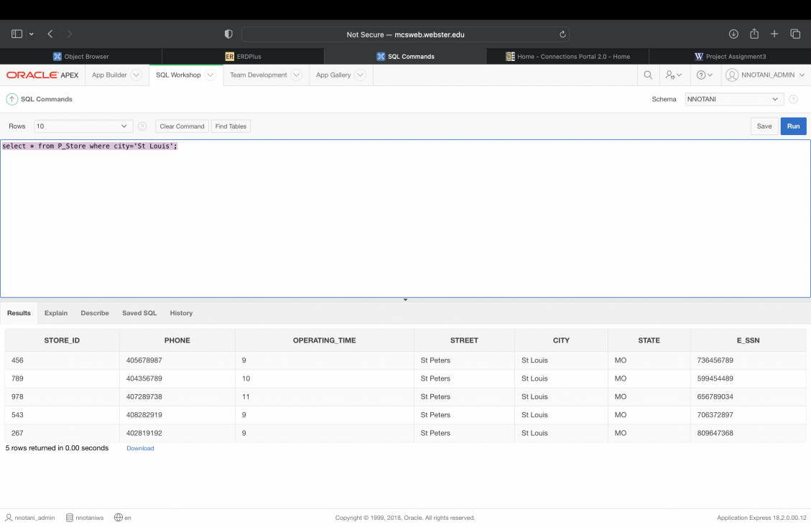

1. **select c.status, o.Order_ID from P_ORDER o inner join P_Car c on o.Order_ID=c.Order_ID where status='ACTIVE';**

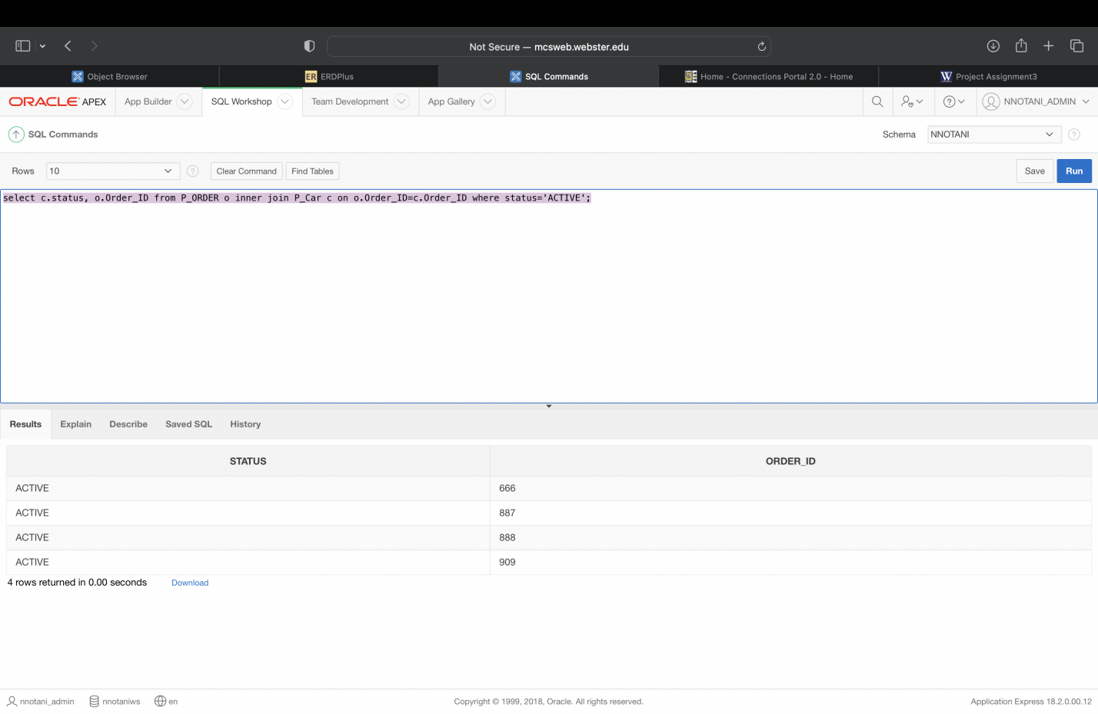

1. **select * from P_Store where Operating_time>9;**

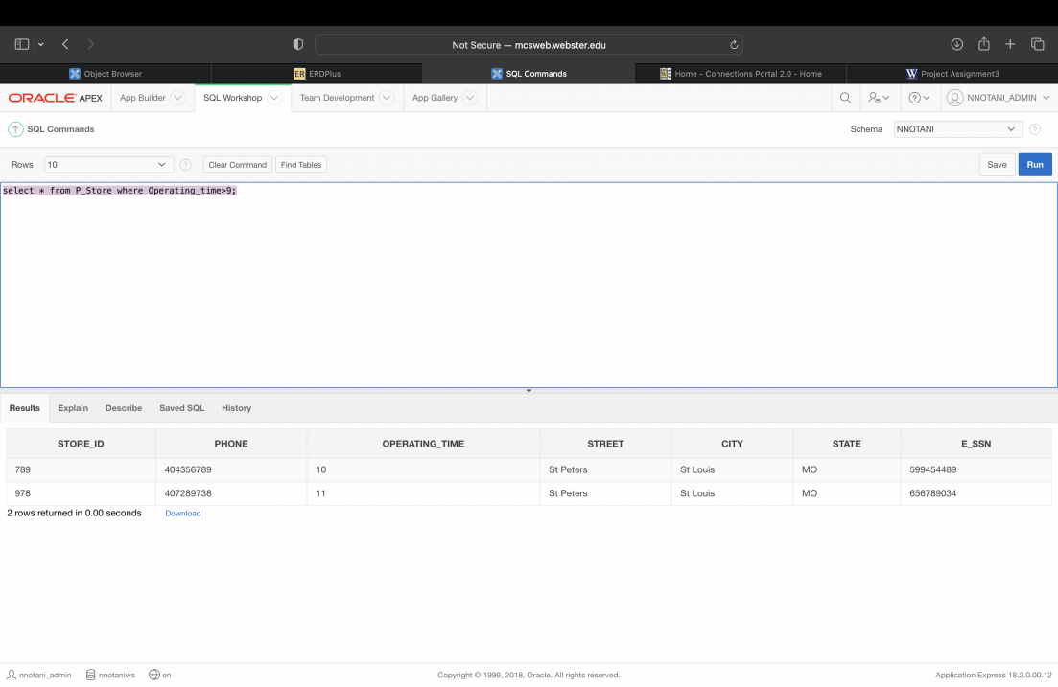

1. **select * from P_STORE_EXECUTIVE where WORKING_TIME>40;**

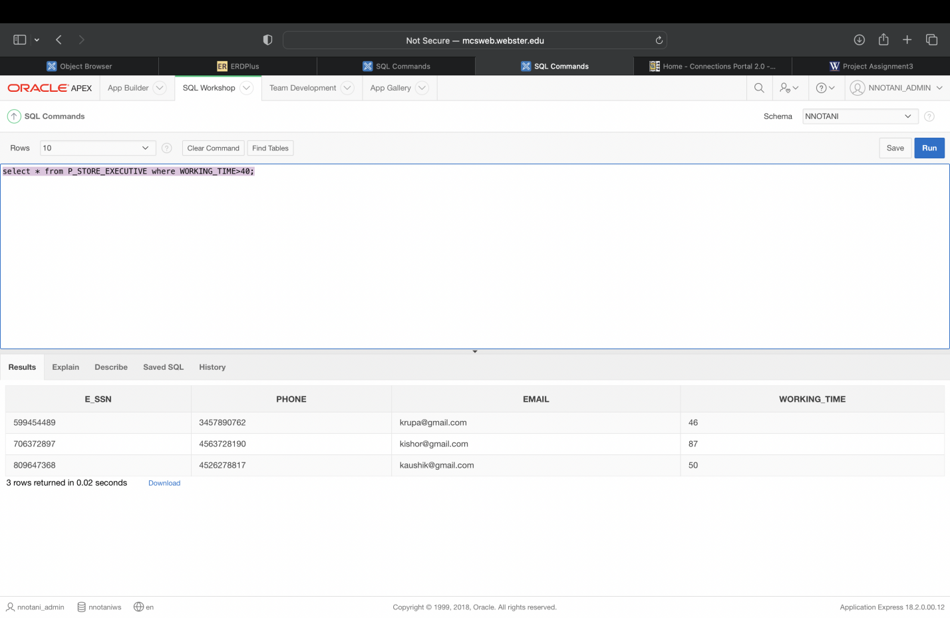

# Screen Shots of created tables (1 each), ‘Data’ tab

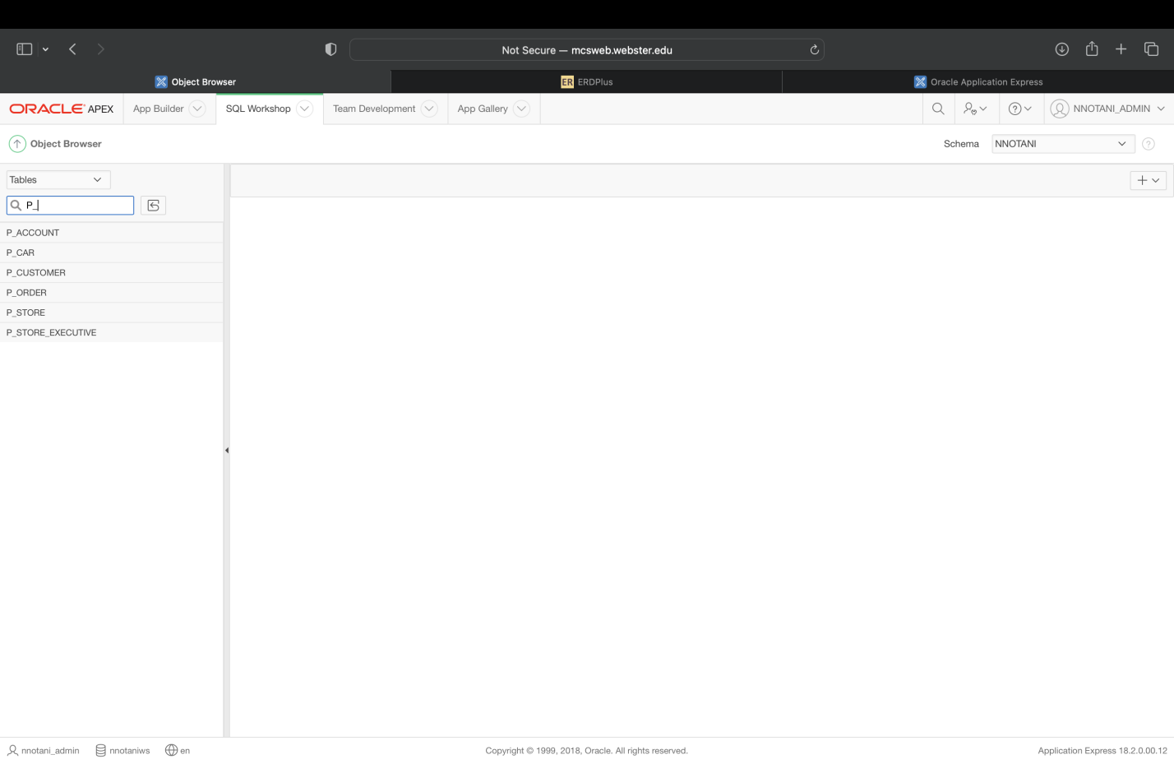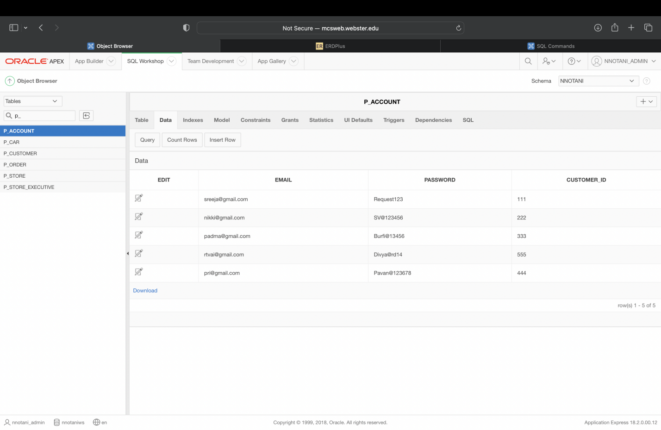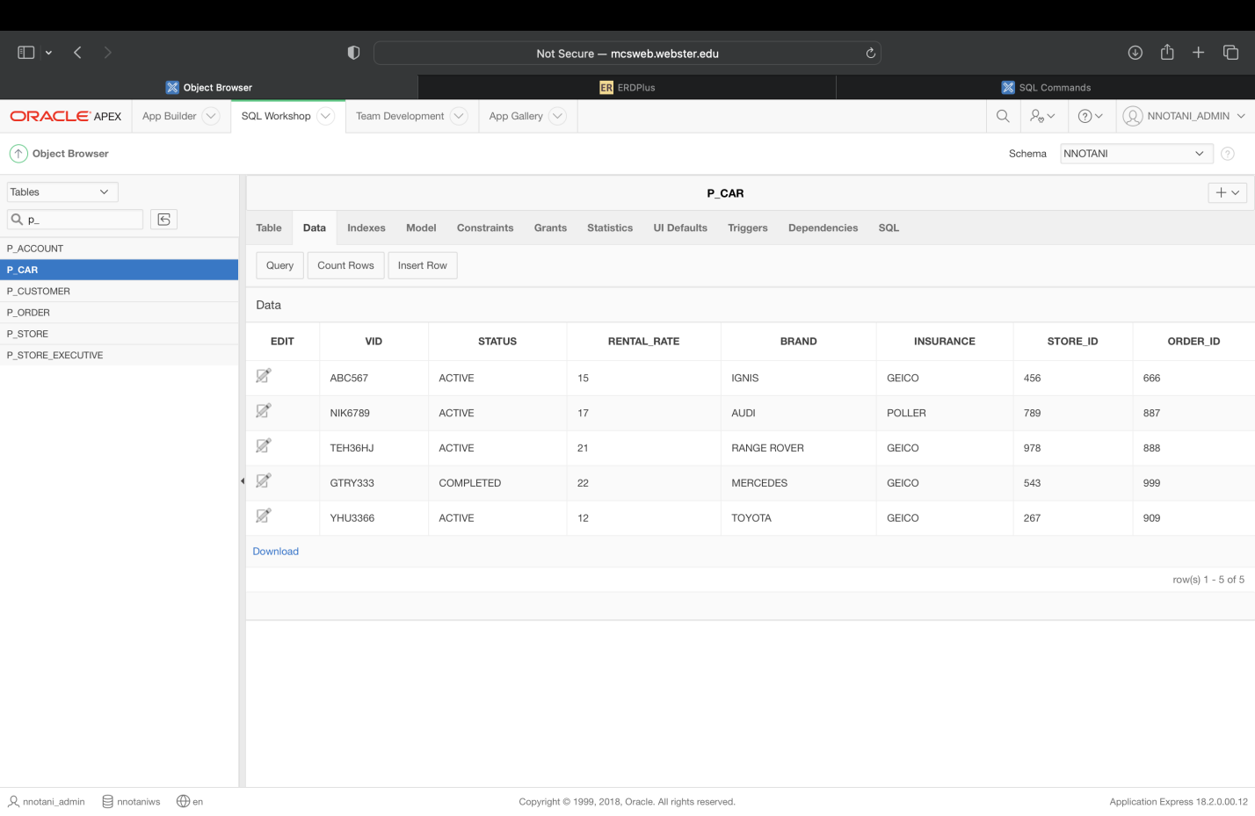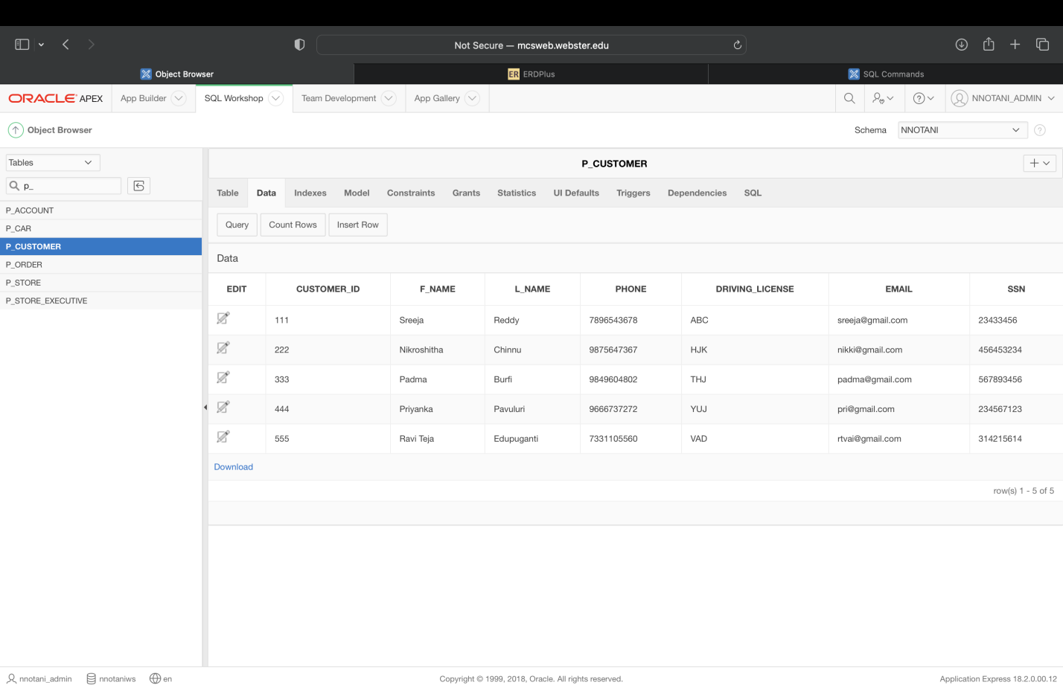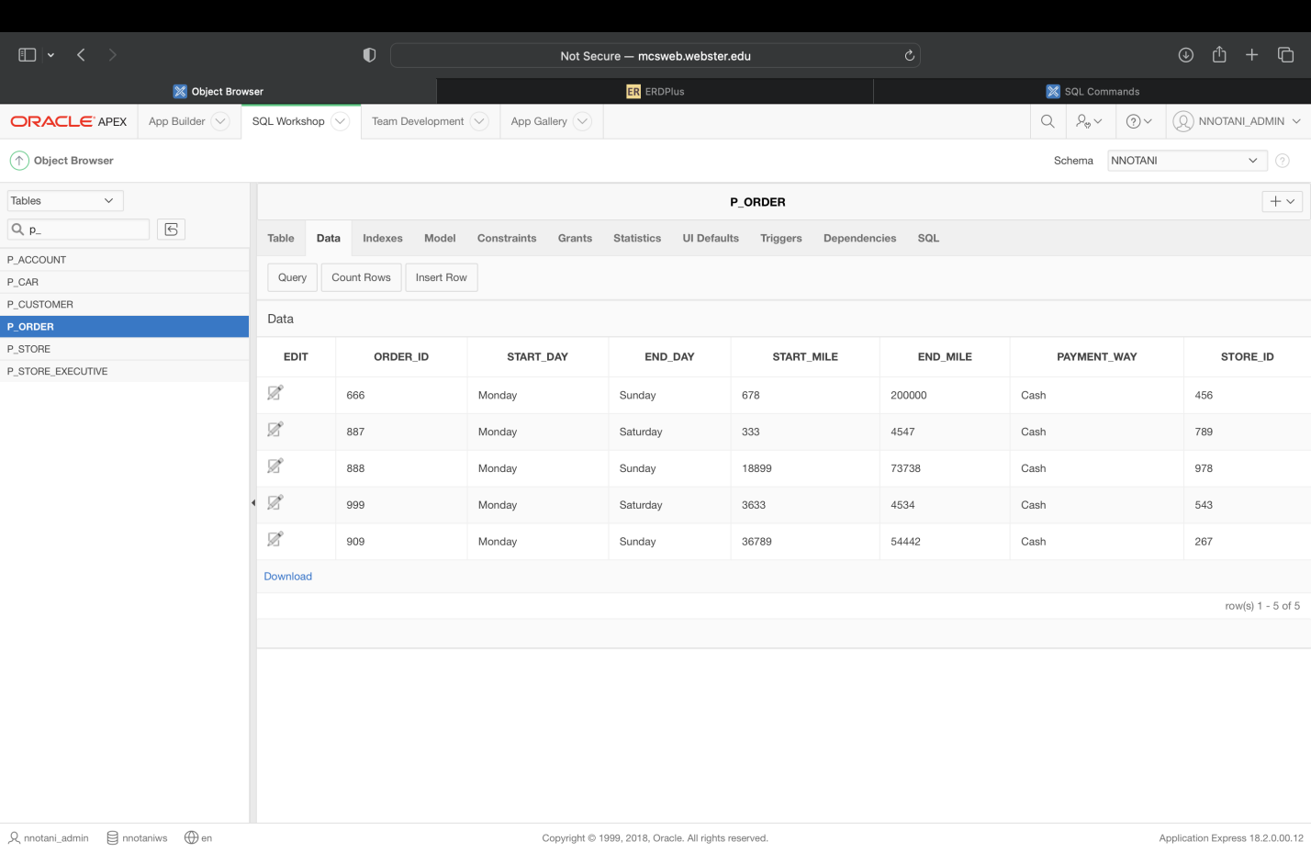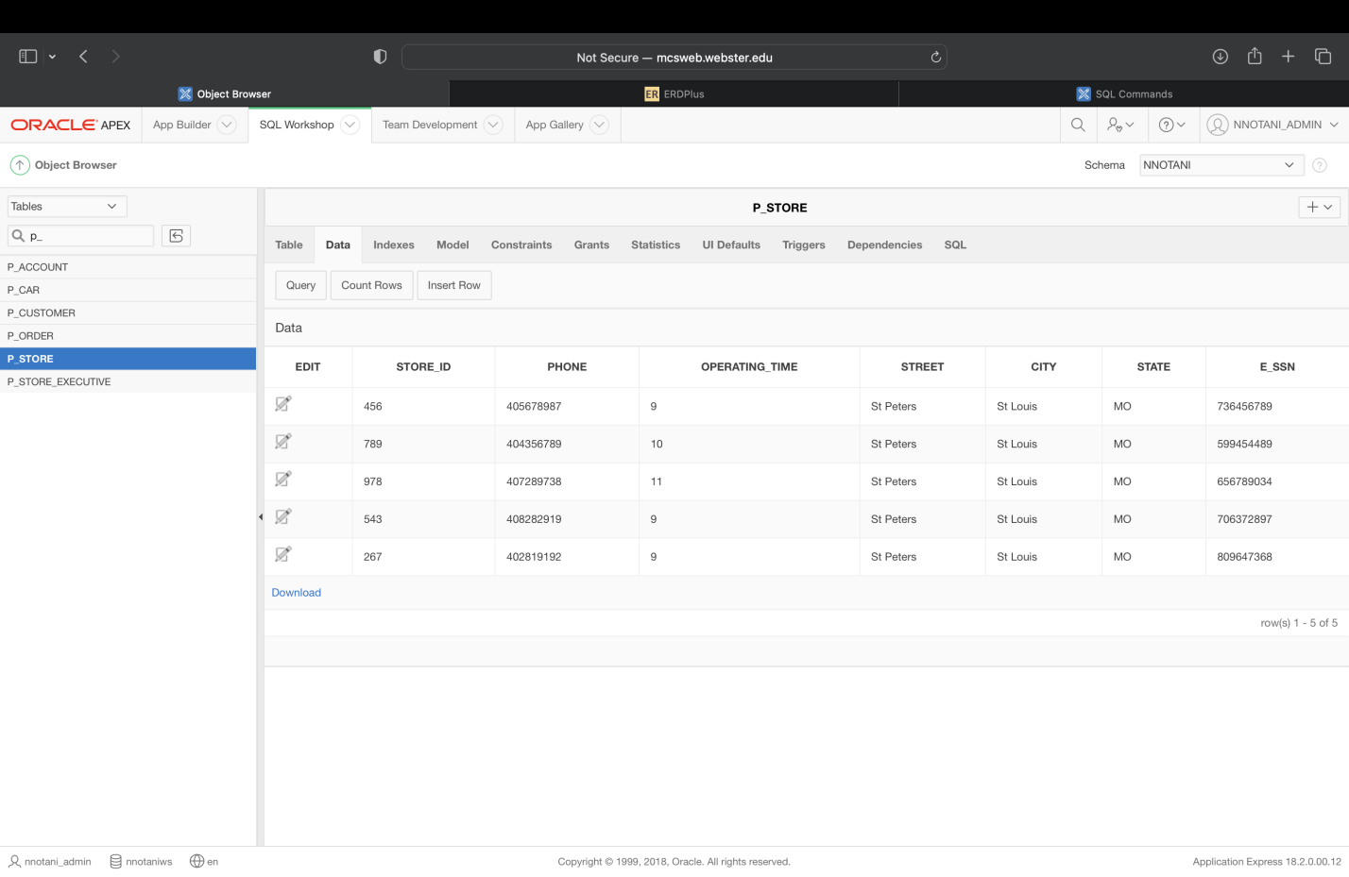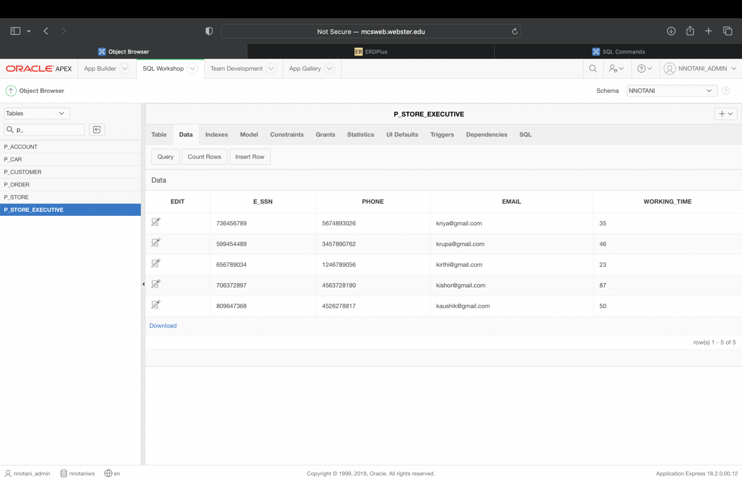

# Data Warehouse Statement of Purpose

Considering the Car Rental system, we would like to have a data warehouse based on the operational database. The chosen subject of analysis is Renter Status. We would like to analyze the payments based on the following: CUSTOMER, ACCOUNT, STORE , VEHICLE.

This would help us know the Number of cars in use and which make and model year is with which customer and which store is open till which time so that a customer can visit for a rental purpose.

# Data Warehouse Model

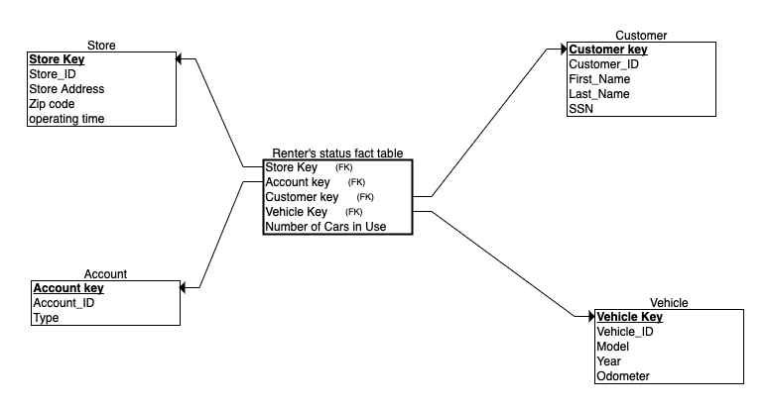

# Data Warehouse Sample Data

|  |  |  |  |  |
| --- | --- | --- | --- | --- |
|  |  |  | **Store** |  |
| **Store_key** | **Store_ID** | **Store Address** | **Zip Code** | **Operating Time** |
| 1 | 456 | Saint Peters | 63456 | 9 |
| 2 | 789 | Saint Charles | 65646 | 10 |
| 3 | 978 | Webster Grove | 64553 | 11 |
| 4 | 543 | Maaryland Heights | 63043 | 9 |
| 5 | 267 | Creve Core | 63256 | 9 |

|  |  |  |
| --- | --- | --- |
|  | **Account** |  |
| **Account Key** | **Account_ID** | **Type** |
| 1 | 101 | New |
| 2 | 102 | Existing |
| 3 | 103 | VIP |
| 4 | 104 | New |
| 5 | 105 | New |

|  |  |  |  |  |
| --- | --- | --- | --- | --- |
|  |  |  | **Customer** |  |
| **Customer Key** | **Customer_ID** | **First Name** | **Last Name** | **SSN** |
| 1 | 111 | Sreeja | Reddy | 23433456 |
| 2 | 222 | Nikroshitha | Chinnu | 456453234 |
| 3 | 333 | Padma | Burfi | 567893456 |
| 4 | 444 | Priyanka | Pavuluri | 234567123 |
| 5 | 555 | Ravi Teja | Edupuganti | 314215614 |

|  |  |  |  |  |
| --- | --- | --- | --- | --- |
|  |  |  | **Vehicle** |  |
| **Vehicle Key** | **Vehicle_ID** | **Model** | **Year** | **Odometer** |
| 1 | 123 | KIA | 2008 | 11122 |
| 2 | 345 | NISSAN | 2009 | 17236 |
| 3 | 567 | AUDI | 2014 | 253566 |
| 4 | 778 | MERCEDIS | 2017 | 25525 |
| 5 | 568 | Lexus | 2020 | 262627 |

|  |  |  |  |  |
| --- | --- | --- | --- | --- |
|  |  |  | **Renter status Fact Table** |  |
| **Store_key** | **Account Key** | **Customer Key** | **Vehicle Key** | **Number of Cars in Use** |
| 1 | 1 | 1 | 1 | Kia - 10 |
| 2 | 2 | 2 | 2 | Nissan - 21 |
| 3 | 3 | 3 | 3 | Audi - 20 |
| 4 | 4 | 4 | 4 | Lexus - 32 |
| 5 | 5 | 5 | 5 | Mercidis - 20 |

# Slides for Presentation

